**Full Stack Development – Lab**

MongoDB & Mongoose

**Developer Note:**

1. Install MongoDB  
   <https://www.mongodb.com/try/download/community>
2. Try and use the Studio 3T to work on MongoDB queries  
   <https://studio3t.com/download/>
3. Alternative to 3T Studio : Mongo Compass for viewing collections and documents

<https://www.mongodb.com/try/download/compass>

1. Working on queries directly in the node application and outputting Json response is acceptable also.
2. Save the queries in a javascript file for submission ie. ex.js

**References:**

* <https://www.tutorialspoint.com/mongodb/mongodb_query_document.htm>
* <https://www.youtube.com/watch?v=eusWqXzo4ec>

**3T Studio Setup:**

1. Launch Robo 3T Studio application from start menu. If it is not installed, then run the install from the following location: <https://studio3t.com/download/>
2. File menu >> Connection and open the MongoDB Connection interface  
   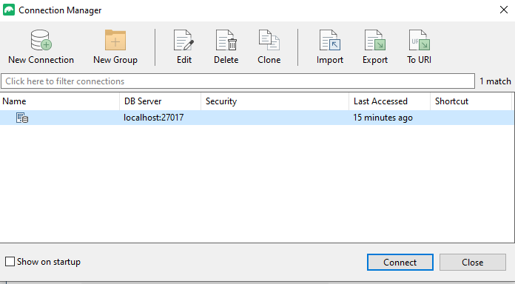
3. Click Connect and launch the studio. Inspect the collections on the left panel

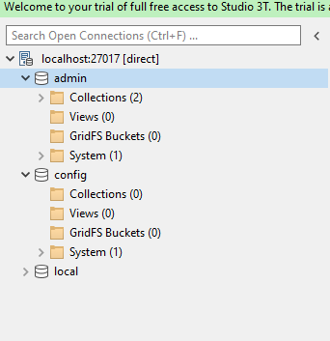

1. Right click on a collection and open the intellishell for queries.

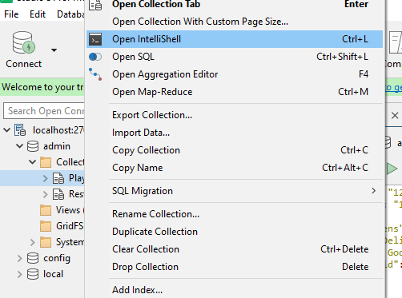

1. The shell will allow you to build queries and execute

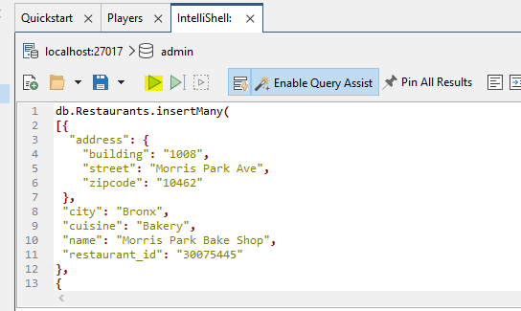

**Exercise 1: Creating Collections and Documents**

1. Use the seed data script found here.   
   <https://drive.google.com/open?id=13u4Kx1cPonjGj6y6imyH0DFuxt9ECWRE>

Use the MongoDb **dbo.collection.insert()** command to insert into the Restaurant collection and paste it into the query panel. Then click the execute button (found in the upper left toolbar) to run the script.

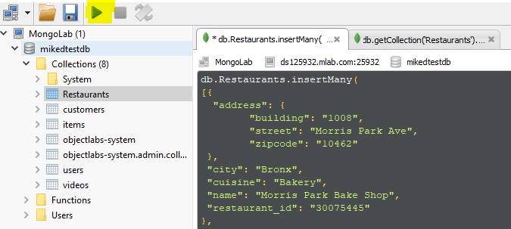

1. In the same query panel workspace use the MongoDb **db.collection.find()** command to view the documents.  
   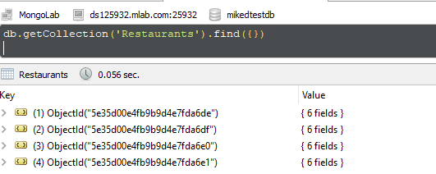
2. Change the result set from tree view to tabular view, by click the following button on right toolbar.  
   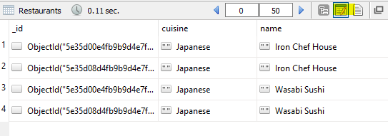

**Exercise 2: Projections, Query and Sorting**

There are three main components of the MongoDB query:  
 1. Filter — Query  
 2. Select Columns (Fields) — Projections  
 3. Sort

1. Type the following **query** to filter the result set to only return the Japanese cuisine. Then execute the query.  
   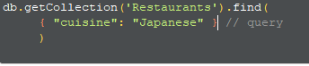
2. Using **projections** to select we can select which columns to either include ‘1’ or exclude ‘0’ in the query.  
   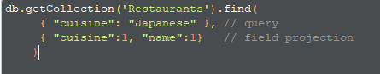
3. We can sort the collection result set by using the **cursor.sort()** method. Use ‘1’ for Ascending Order and ‘-1’ for Descending Order.
4. **Write a query that will do the following**  
   1. Filter on ‘Japanese’' cuisine using the **$eq** logical operator   
   2. Include the id, cuisines, name and city, resturant_id columns.   
   3. Sort the restaurant_id in Ascending Order.  
   Below is the expected result set.   
   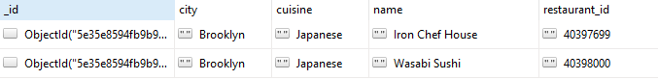

**Exercise 3: Logical and Comparison Operators**

<https://docs.mongodb.com/manual/reference/operator/query-comparison/>  
<https://docs.mongodb.com/manual/reference/operator/query-logical/>

1. We can use the **‘$eq’ operator** to be more explicit in our query for cuisine. Using comparison operators we can use both **‘$eq’ equal** operator and the **‘$ne’ not equal** operator.  
   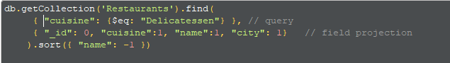
2. Write a query that uses the **$and** logical query operator, **$eq** and **$ne** comparison query operators.

The query must return the following:

1. All cuisines that are **equal** to Delicatessen **and** the city is **not equal** to Brooklyn
2. The selected columns must include cuisines, name and city, but exclude id
3. The sorting order must be Ascending Order on the name

The following query will return the following result:  
  
 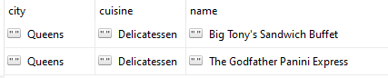

**Exercise 4: Multiple Operators**

Use the $and operator to create multiple conditions. <https://docs.mongodb.com/manual/reference/operator/query/and/>

Build a query that does the following:

* Using the **$in** operator filter the **cuisines** that are "Bakery", "Chicken", "Hamburgers", "American"
* Using the **$ne** operator filter out the documents that have **city** "Brooklyn"
* Using the **$gt** operator include only documents that have **restaurant_Id** greater than 4000000
* Exclude columns _id. Include cuisine, name, city, restaurtant_id
* Sort Descending on **restaurant_id**

The following query will return the following result:  
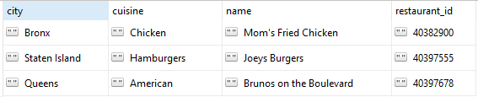

**Exercise 5: Filtering on Array Columns**

We can filter on the nested array data in the following way:

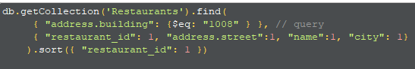

To correctly, output the address street we need to flatten out the array via aggregation. This is something we will learn in this week’s lecture.

We can search wildcard values using the dollar $ operator in the following way



Write a query that does the following:

Returns a result set where the name is contains "Thai", or the address street contains "Street" or the the address zip code equals 17988